HEAR ME… Voices from a Care Home during the Covid 19 Pandemic

Anna Mankee-Williams and Ruth Heholt

Bethan Michael-Fox

HEAR ME… Voices from a Care Home during the Covid 19 Pandemic is a short, beautifully bound little hardback book written by two researchers at Falmouth University, Anna Mankee-Williams and Ruth Heholt. The book brings the voices of staff in a Cornish care home to the page. It focuses on an overflow discharge project to take patients leaving hospital in as temporary residents to ease pressure on the NHS. The illustrations are by CF Sherratt. The book has been produced locally in Cornwall by Luke Thompson and printed and bound by Palace Printers in Lostwithiel.
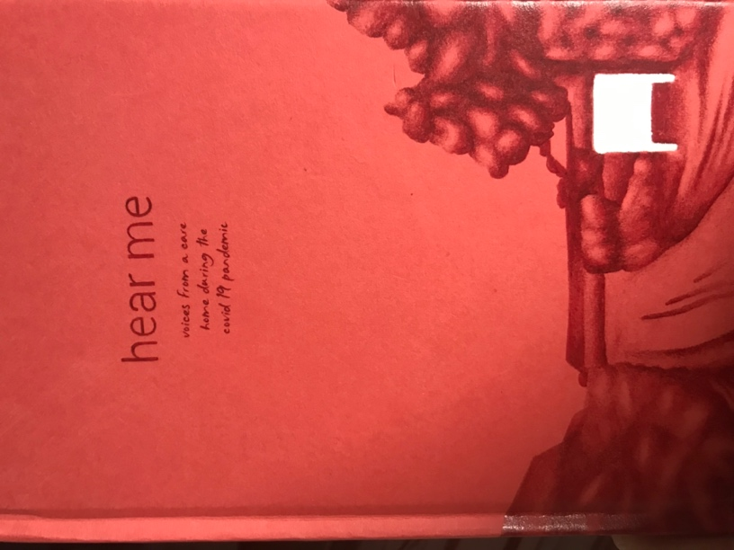
The interviews that form the basis of the book were undertaken in a care home involved in a national project to care for people who were deemed ready to leave hospital but for whom no onward care arrangements were yet made – those without a positive Covid-19 test whose hospital beds were needed for incoming patients. Mankee-Williams and Heholt spoke to staff and residents, listening to their experiences of both the project and their work and lives in the context of Covid-19 more broadly. The book also includes the moving testimony of a family member whose mother died in the home.

The book is positioned and functions effectively as an oral history project, concerned with exposing a pervading bias and ‘othering’ of care homes and their staff in the broader sociopolitical context. The book challenges negative stereotypes of carers and contemplates the possibilities and barriers to an integrated health and social care system in England.
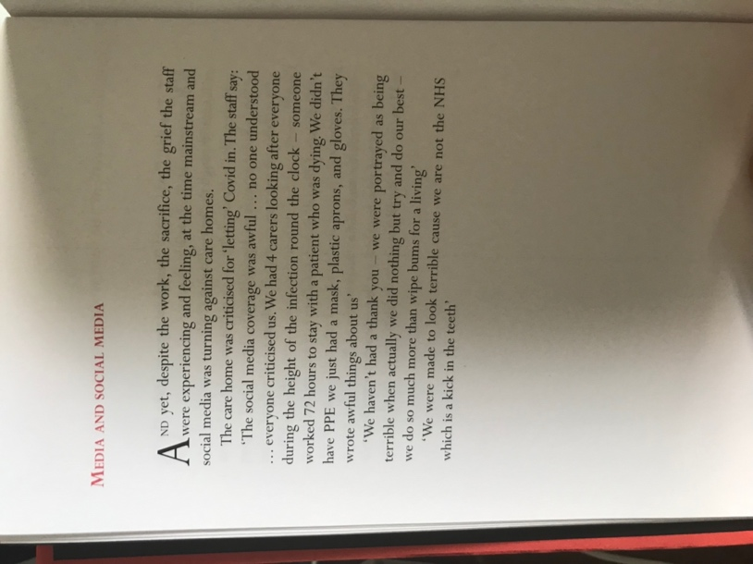
The authors are explicit about wanting to ‘surface celebratory narratives of how in the most challenging of circumstances, being human and caring matters and makes a difference.’ They emphasise that those who work in care homes, a ‘predominantly female, non-graduate workforce’, are often ‘othered’. They consider the ways that language masks this ‘othering’, and how it operates to position social care as outside the NHS, but not as a business either – as a kind of hinterland between NHS provision (celebrated but insufficiently materially supported, both during and prior to the pandemic) and businesses (the Covid-19 support measures for which, according to carers interviewed for this book, were never discussed much publicly in relation to care homes). The extent to which care homes are ‘in’ or ‘out’ of the NHS is foregrounded, with carers reflecting on language that emphasises their position as privatised and part of a market (as much of the NHS is, too, though this is often downplayed in political discourse).

The focus on language in the book also considers how terms such as ‘medically optimised’ (to describe a patient deemed well enough to leave hospital) and ‘bed blocker’ (to describe someone deemed well enough to leave hospital but with no onward place to go) function to dehumanise people experiencing and requiring care. The language used in the book to discuss older people, residents and patients is not always as relational as it might be, with the much-critiqued term ‘elderly’ deployed at times (see, for example, Avers et al. for a critical discussion of the term). This may well be a consequence of the book having been produced quickly. Whilst the book has a contemplative tone, it also emits an urgency – a desire to bring the voices in the book to light whilst the height of the pandemic remains fresh in people’s minds.

The mainstay of the voices in the book are those of staff. This is a valuable focus, and any projects that develop from the work might be more explicit in stating engagement with staff as the main aim or outcome. When the voices of patients, residents and family emerge, they are positive reflections on the staff and on the difference between their experiences of care in hospital and in the care home. The story of one family member whose mother died in the home is heartwarming to read. Centrally, however, the book brings to the fore the voices of those delivering care, giving a sense of the challenges they faced, the skills they developed, and the grief they were both exposed to and experienced themselves.

Visually, the book is striking and tactile. It has short sections of text with red, capitalised headings and plenty of blank space, as well as red, white, and black illustrations. The blank, white space foregrounds the words of those interviewed, but also serves as a reminder of how much of the reader will come to these pages.
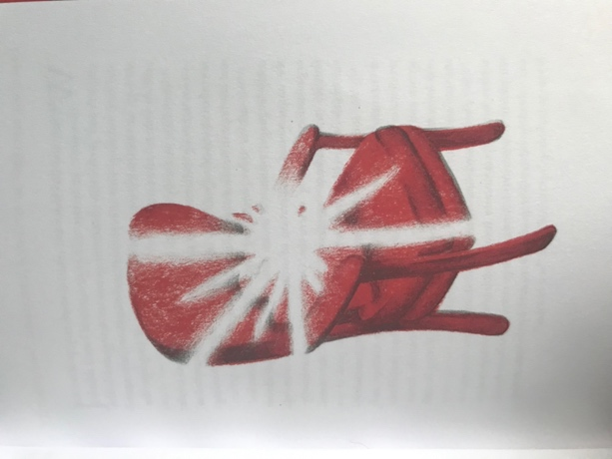

In the last year or so, as I’ve caught up with people after restrictions eased, I have listened to the stories of many women (always women, though perhaps this isn’t telling of much other than that most of my friends are women) who have had harrowing experiences with care homes. They have resonated with experiences in my own family before Covid-19, where care homes have been a part of painful, difficult, complicated periods of separation, family conflict and loss. The idea of the care home in lived experience and in people’s imaginations is a complicated thing, or at least it is for me. There are those who fear being in a care home based on what they’ve witnessed, what they’ve heard, what they know. There are many whose separation from loved ones due to lockdowns has constituted a profound hurt, and these challenges are not over. They aren’t unique to Covid-19 either – my own experience speaks to painful separation before the pandemic, when the complexities of permissions and extended family dynamics kept loved ones apart. The blank spaces in the book bring to my mind so many other stories – real and imagined, hopeful and devastating, past and present. The use of evocative illustrations, the blank spaces, and the focus on fairly decontextualised voices in the book allow it to function as a prompt, a conversation starter, and an invitation to think more.
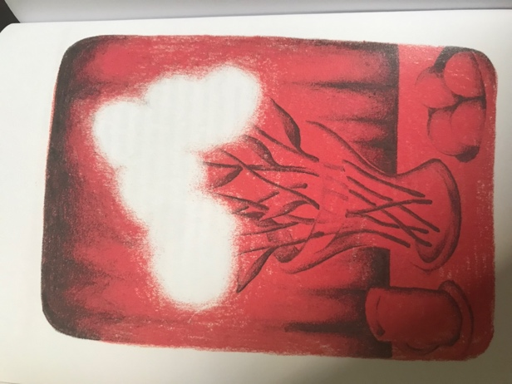
I will admit I find it hard to get past my own difficult relationship to care homes. Now as I write this review, I am preparing to go back to work from maternity leave. I’ll be going back to teaching on an English module that includes a series of videos made inside a care home (pre-Covid-19) with staff and residents (used in the module to teach about communication and language). That material, and the voices in this book, circulate in my mind and offer much needed insight into different experiences. Whilst so many screen and other visual representations of care homes create a sense of blankness, absence, clinical coldness, and unhomeliness, this lovingly made and thought-provoking book paints a portrait of a vibrant, caring space.

To purchase a copy of the book, contact ruth.heholt@falmouth.ac.uk

References

Avers, Dale DPT, PhD; Brown, Marybeth PT, PhD, FAPTA; Chui, Kevin K. PT, DPT, PhD, OCS, GCS; Wong, Rita A. PT, PhD; Lusardi, Michelle PT, DPT, PhD Use of the Term “Elderly”, Journal of Geriatric Physical Therapy: October/December 2011, Vol. 34, Issue 4, p.153-154 doi: 10.1519/JPT.0b013e31823ab7ec

